**Meeting discussion points:**

1. **Cellular-first vs. Satellite-first**
   * *Satellite-first* is currently not feasible in my opinion - far too expensive. R0.43 per message might not seem much but sending data every minute (43,200 messages/month) would cost ±R18,550 monthly per device!
   * *Alternative approach*: Adopt a **cellular-first base** that supports expansion modules, ensuring satellite can be added later when it becomes cost-effective (e.g., Swarm, Astrocast, Starlink) or on critical lines/services now.
   * Cellular covers ±95% of lines. Store-and-forward ensures full-trip data logging (with only ±5% not available in real-time).
2. **Microcontroller (e.g., ESP32) vs. Single-board computer (e.g., Raspberry Pi Zero 2W) vs. Custom Industrial-grade PCB (future production)**
3. **APN vs. Proxy/Gateway Server vs. MQTT Broker as a gateway**
4. **Test Databases (created on 10.203.64.79):**
   * SQL Server (completed)
   * PostgreSQL (completed)
5. **Next Steps (if agreed):**
   * Procure components for prototyping (±R5,000 for cellular + LoRa, optional R5,000 for satellite module)
   * Obtain APN test SIM
   * Develop prototype software (firmware + backend + frontend)
   * Conduct field testing
   * Attempt integration with existing systems (ITP, TMS, VDU)
     1. Immutable Train Registry - Unique Forever, Single Source Truth
     2. Automated Data Validation Engine (confidence score > 0.75):
        1. GeospatialValidator() – Detects impossible movements
        2. TemporalValidator() – Ensures time consistency
        3. CompositionValidator() – Verifies vehicle list integrity
        4. RouteValidator() – Validates path compliance
        5. CrossSystemValidator() – Checks ITP/TMS/VDU consistency
        6. Machine learning?
   * Evaluate results and propose the way forward

**Communication Strategy**

|  |  |  |  |  |
| --- | --- | --- | --- | --- |
| **Module** | **Coverage** | **Monthly Cost** | **Regulatory Status** | **Use Case** |
| **Cellular (Base)** | 99%+ urban/main routes | R50 | ✅ Approved | Primary tracking |
| **LoRa (Optional)** | Depot areas, gateways | R0 | ✅ Approved | Cost optimization |
| **Iridium Satellite** | 100% global | R18,550 | ✅ ICASA Approved | Emergency/critical only |
| **Astrocast (Future)** | 100% global | R5,123* | ⏳ Pending ICASA | Potential cost-effective option |
| **Swarm (Future)** | Limited global | R3,309* | ⏳ Pending ICASA | Potential budget option |

**Expansion Module Configurations**

|  |  |  |  |  |
| --- | --- | --- | --- | --- |
| **Route Profile** | **Base + Expansion** | **Monthly Cost** | **Coverage** | **Operational Benefits** |
| **Urban Standard** | T-SIM only | R50 | 99% | Real-time tracking, proven reliability |
| **Main Line Optimized** | T-SIM + LoRa | R50 | 99% | Real-time + zero-cost depot communication |
| **Remote/International** | T-SIM + Satellite (emergency) | R50 (+R18,550 when activated) | 100% | Emergency communications only |
| **Depot Economical** | T-SIM + LoRa (cellular off) | R0 | 95% | Zero operational costs for yard operations |
| **Emergency Backup** | T-SIM + LoRa + Satellite (emergency) | R50 (+R18,550 when activated) | 100% | Emergency backup only |

Here is the highlight of the proposal:

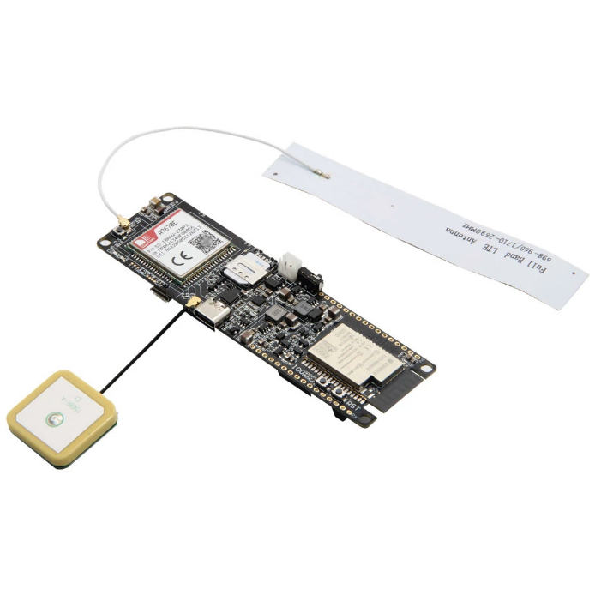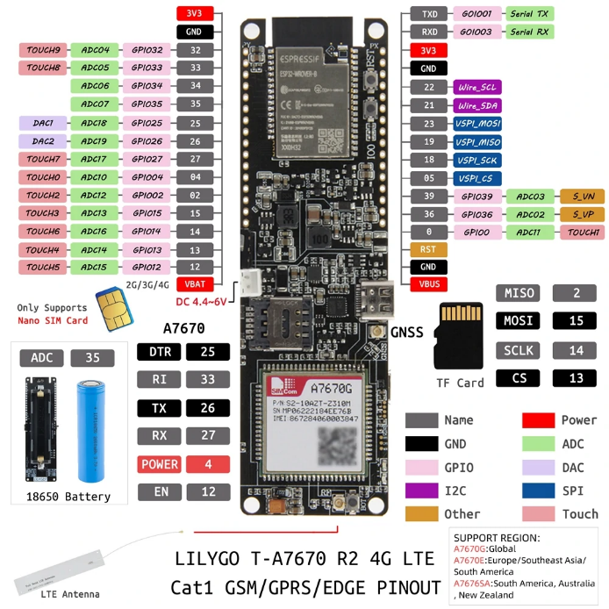

**Hardware (R3,375 Cellular base + R300 LoRa + R4,850 Iridium)**

* **Core Platform**: LILYGO T-A7670G R2 Q425 (ESP32-WROVER-E + LTE CAT-1 + L76K GPS)
* **Enhanced UI**: 2.8" color TFT display (320x240), 4-button navigation pad, multi-color status LEDs
* **Expansion**: Optional LoRa and satellite communication modules
* **Power**: Railway power with 48-hour battery backup
* **Environment**: IP67 rated, -20°C to +70°C operation

**Software**

* **Embedded**: C++ on ESP32 using PlatformIO with OTA support and train management workflows
* **Backend**: .NET Core Web API with Entity Framework and train management integration services
* **Database**: MS SQL Server with spatial data extensions and train management tables
* **Frontend**: React.js dashboard with real-time mapping and fleet management
* **Communication**: MQTT over TLS for secure data transmission and train assignment commands
* **Integration**: Direct API connectivity with Transnet ITP, TMS, and VDU systems
* **OTA System**: Secure firmware updates with rollback protection

**Network**

* **Primary**: Cellular (4G/3G/2G) via private APN
* **Optional**: LoRa 868MHz for depot areas
* **Optional**: Satellite (Iridium) for remote routes